Assignment # 3

This assignment # 3 pertains to the requirement analysis and usability phases of your project.

For the project that you have selected in earlier phase, you are required to do

**Phase3: Requirement Analysis**

1. Define all the functional and non-functional requirements of your project.
2. Develop complete use case diagram and define use cases with narratives.
3. Finally, you need to develop an ERD/data flow or sequence diagram, whichever suits your project.

PS: All database projects should opt for and develop ERD diagram.

**Phase 4: Usability**

1. Design the user interface using paper prototype and wireframes for your project. Follow all the rules that are discussed in the lecture.

**Main use case diagram**

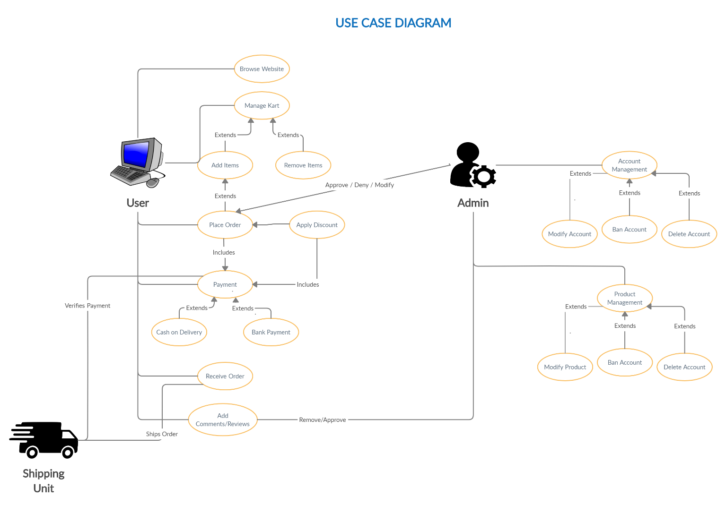

**Sub use cases with narratives**

* 1. **User Login to the system**

|  |  |  |
| --- | --- | --- |
| **Use Case Name:** | Login | |
| **ID:** | OM-01 | |
| **Actors Involved:** | Customer, Administrator | |
| **Brief Description** | Actor enters the email address and password to login to the system. | |
| **Pre-Conditions** |  | |
| **Post-Conditions** |  | |
| **Normal Flow of Events:** | **Actor Action** | **System Response** |
| 1. Enter email address and password. 2. Clicks the submit button. | 1. System displays the actor mail page on successful login. 2. System displays error message on invalid login. |

* 1. **User Adds to Cart**

|  |  |  |
| --- | --- | --- |
| **Use Case Name:** | User Cart | |
| **ID:** | OM-02 | |
| **Actors Involved:** | Customer | |
| **Brief Description** | Actor Adds/Removes products from the cart. | |
| **Pre-Conditions** | OM-01 | |
| **Post-Conditions** | Addition/Removal of products from user cart. | |
| **Normal Flow of Events:** | **Actor Action** | **System Response** |
| 1. Click on “Add to cart” on products 2. Click “Remove” option in the user cart page. 3. Click “Clear Cart” in the User Cart page. | 1. System adds the product into the cart. 2. System deletes the product from the cart. 3. System clears all the products in the cart. |

* 1. **User makes payment**

|  |  |  |
| --- | --- | --- |
| **Use Case Name:** | Payment | |
| **ID:** | OM-03 | |
| **Actors Involved:** | Customer | |
| **Brief Description** | Make payment for the product | |
| **Pre-Conditions** | OM-02 | |
| **Post-Conditions** | Approval of the user order. | |
| **Normal Flow of Events:** | **Actor Action** | **System Response** |
| 1. Go to the cart and click “Proceed to checkout” 2. Select payment method (COD or Bank) 3. Click on “Order Now” | 1. System navigates to checkout. 2. System sets the desired payment method. 3. System generates the amount receipt and place order by using selected payment method. |

* 1. **User adds reviews**

|  |  |  |
| --- | --- | --- |
| **Use Case Name:** | Adding Review | |
| **ID:** | OM-04 | |
| **Actors Involved:** | Customer | |
| **Brief Description** | User adds review to the product. | |
| **Pre-Conditions** | OM-03 | |
| **Post-Conditions** | Review added to the product. | |
| **Normal Flow of Events:** | **Actor Action** | **System Response** |
| 1. Hover at the bottom of the product, fill the textbox and grading. 2. Click on “Submit review” | 1. - 2. System publishes the review to the product. |

* 1. **Administrator deletes review**

|  |  |  |
| --- | --- | --- |
| **Use Case Name:** | Deleting Review | |
| **ID:** | OM-05 | |
| **Actors Involved:** | Administrator | |
| **Brief Description** | Removing reviews from the product. | |
| **Pre-Conditions** | OM-04 | |
| **Post-Conditions** | Deletes review from the product. | |
| **Normal Flow of Events:** | **Actor Action** | **System Response** |
| 1. Hover at the bottom of the product 2. Click on “Delete Review” | 1. - 2. System deletes the review from the page. |

* 1. **Administrator Rejects Order**

|  |  |  |
| --- | --- | --- |
| **Use Case Name:** | Rejecting Order | |
| **ID:** | OM-06 | |
| **Actors Involved:** | Administrator | |
| **Brief Description** | Removing the user order(s). | |
| **Pre-Conditions** | OM-03 | |
| **Post-Conditions** | User order gets rejected. | |
| **Normal Flow of Events:** | **Actor Action** | **System Response** |
| 1. Hover to the admin panel 2. Select the order to be rejected, place the reason in the textbox and click on “Reject”. | 1. System navigates to Admin panel 2. System will delete the order and send a corresponding notification to the user with the reason. |

* 1. **Account Management**

|  |  |  |
| --- | --- | --- |
| **Use Case Name:** | Account Management | |
| **ID:** | OM-07 | |
| **Actors Involved:** | Administrator | |
| **Brief Description** | Managing user account (Performing Ban, Delete and Modify functions) | |
| **Pre-Conditions** |  | |
| **Post-Conditions** |  | |
| **Normal Flow of Events:** | **Actor Action** | **System Response** |
| 1. Hover to the admin Panel. 2. Search/Select the user account to be managed. 3. Click on Ban / Delete / Modify account to process relevant function. | 1. System navigates to Admin panel. 2. System selects the account(s). 3. System deletes/Bans/Modifies the account. |